Learn More about Tsunami
The word “tsunami” comprises the Japanese words “tsu” (meaning harbor) and “nami” (meaning wave). Tsunami are a series of waves created by an underwater disturbance, usually associated with earthquakes occurring below or near the ocean. Large landslides or volcanic activity can also trigger a Tsunami. These rare events can be extremely deadly—in the past 100 years, 58 of them have claimed more than 260,000 lives, or an average of 4,600 per disaster, surpassing any other natural hazard. If you live near or visit the coast, learn about Tsunami risk and what to do if you are under a Tsunami Warning.
Tsunami can travel as fast as 20-30 miles per hour and can have waves from 10-100 feet high. Tsunami can cause great disruption with flooding, power interruption, communication interruption and tainted water supplies. All US coastal areas have potential for Tsunami. When heading for higher ground try to get 100 feet above sea level and one mile inland.
In some cases an earthquake can be felt before the Tsunami occurs. If you feel a large (strong and long) earthquake and are near the coast this is your warning - get to higher ground and inland as quick as possible (Long, Strong, Get Gone!). Do not wait for official notification. Some earthquakes may be farther away and do not cause ground shaking, but do result in elevated Tsunami risk. If told to evacuate, do so immediately. If you have time check on your neighbors to ensure they are aware and can evacuate quickly.
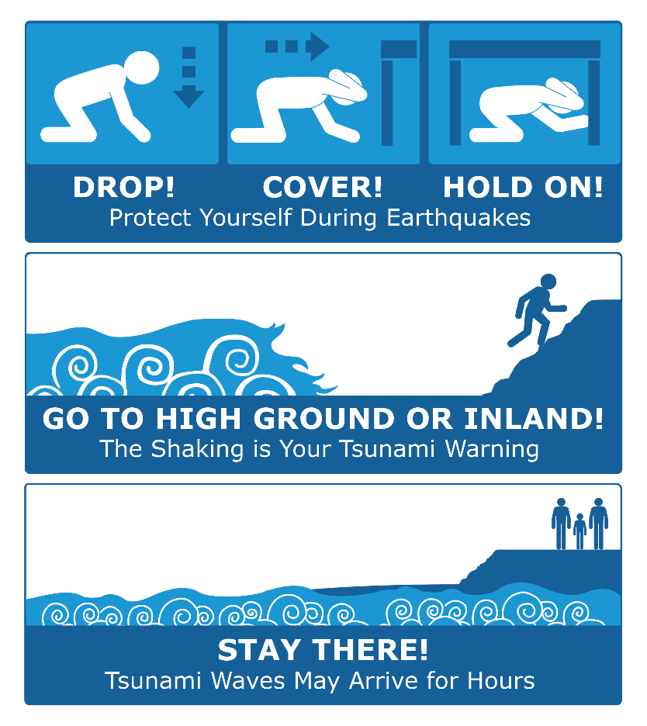
If you are under a Tsunami Warning:
- Get to high ground as far inland as possible. Evacuate, Don’t wait!
- Be alert to signs of a tsunami, such as a sudden rise or draining of ocean waters.
- Listen to emergency information and alerts.
- Check with SoCoEmergency.org for additional details and information like Shelters opening
- Make plans to shelter with friends and family, if possible.
- If you are in a boat, go out to sea.

Learn More:
https://socoemergency.org/get-ready/local-hazards/tsunami/
https://www.tsunami.gov/
https://kamome.humboldt.edu/
https://www.ready.gov/tsunamis

